Computer Repair System
Introduction 2
Modules 3

Introduction
This project encompasses the design, development, and deployment of a software application that manages the entire repair pipeline. The system will handle the full lifecycle of a repair job, including initial intake, diagnostics, parts procurement, and final quality assurance.
When a customer enters the repair shop, a technician will log a ticket for the customer which will contain the customer complaint/fault, customer details, date, computer information etc. A technician will be assigned to the ticket and will continue with the diagnosis.
During the diagnostics/repair process, the assigned technician will be able to write notes and update the ticket status. Upon diagnosing the problem, the technician will generate a quote including parts/labor for the repair upon which the customer will be contacted and consulted on if they want to go through with the repair (‘awaiting customer approval’). The ticket status will reflect the customer’s choice on this, where either the customer will go through with the repair or not.
If parts need to be purchased, the technician will then be able to order the parts for repair. Certain parts might already be in stock/currently held in inventory, so purchasing from supplier might not be necessary. If a part is required for a repair, a technician can ‘reserve’ the part for the repair ticket while awaiting customer approval.
Upon completion of the repair, the system guides the technician through a closure checklist. This finalizes the ticket, calculates associated costs (labor + parts), updates the inventory count to reflect used components, and archives the complete repair history for future reference

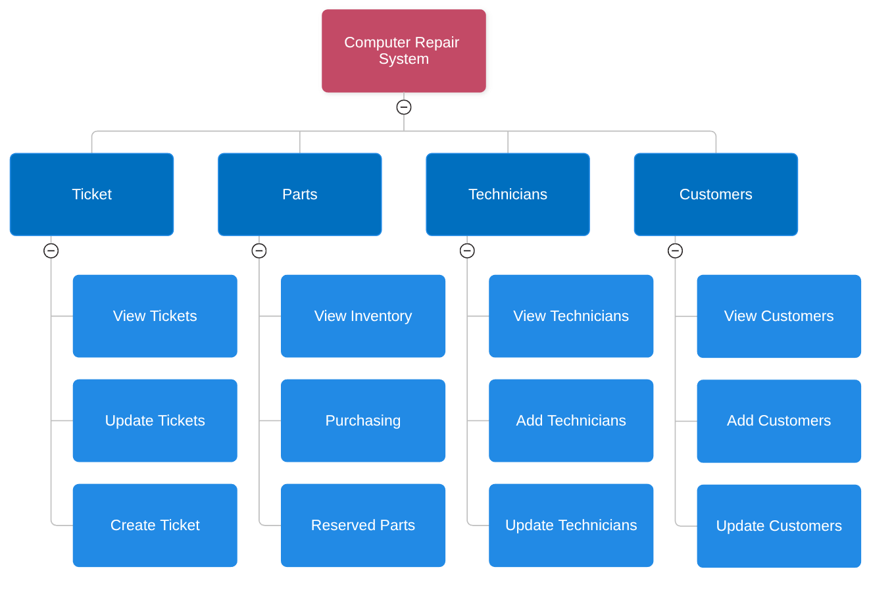
Modules

